Encyclopedia of an Extraordinary School – Cascade High School
Class of 2022 Entry
(based on Amy Krouse Rosenthal’s Encyclopedia of an Ordinary Life)

From Encyclopedia of an Ordinary Life, “Orientation Almanac”:
The following is an attempt to provide the reader, particularly those of you who come to this in a distant and certainly different era, with plain facts about [CHS life from 2017-2022], the backdrop against which this book was written. (Krouse Rosenthanl 1)

The departing members of the Class of 2022 were tasked with creating their class's entry in the Encyclopedia of an Extraordinary School – Cascade High School.

Population (Class Size)
- 46 Students

Top Stories
- Missing half of Sophomore year (COVID shut down March 2020)
- Keagan Lamey getting stung by a bee and Alec Gehl saving his life
- Keagan Lamey falling down the steps and everyone heard it
- Gavin Manternach climbing a tree during Cougar Pride Day
- Davis Trumm being the Iowa Trig-Star (#1 in the State)
- Winning powder puff senior year
- “Lockdown” in Stewart’s room

Cost of Living Averages (school lunch, bottle of pop or water, and so on)
- Gas $4.09 per gallon
- Getting eyebrows threaded $12.00
- At least one caffeinated drink $6
- At least $20 for weekend activities
- Golf – free for team members in-season; offseason: $5 green fee, $5 cart fee
- School breakfast and lunch are free due to COVID

Favorite Television Shows
- YOU
- The Office
- Criminal Minds
- Euphoria
- Grey’s Anatomy
- Law and Order
- Friends
- Bones
- Jeopardy!
- Breaking Bad
- Riverdale
- NCIS
- Selling Sunsets
- Yellowstone
- Heartstopper

Ways We Entertain Ourselves
- Stall class through constant chatting
- Going to guidance office to talk with Steph and Mr. Webber
- Talking to Mr. Stewart during Cougar Time
- Scrolling through TikTok
- Going to the library to avoid class
- Go on a walk and talk
- Napping
- Using the restroom so you can be on your phone
- Sitting in the high school parking lot
- True Crime Documentaries
- Driving around
- Hitting bombs at Fillmore
- Going to Walmart/Target
- Spontaneous road trips
- Watching Netflix
- Getting called out early so you can relax at home
- Bowling at Cherry Lanes

Classes We Recommend (Even if We Hated)
- Precalculus
- Kirkwood classes
- Composition I and II
- Statistics
- History through Media
- Introduction to Literature
- Spanish at least 3 years
- Public Speaking
- AP US History
- Modern US History
- Creative Writing
- Art Exploration
- Technology Solutions (“The Help Desk Class”)

Most Popular School Activity
- Student section at games
- Walk and Talks
- Going to the gym during Cougar Time on Fridays
- Visiting Mr. Webber
- Running to Lunch

Favorite Sayings
- “That’s not my problem.” - Mr. Knepper
- “Today is a workday.” - Mrs. Manternach
- “Happy [Specific Day]!” - Mr. Curry
- “This is super easy.” - Mr. Knepper
- “Hey Team.”- Mrs. Keen
- “No school likely tomorrow!” - Brad Denemark
- “Healthy and eligible on Monday.” - Coach Brindle/Coach McMullen
- “They (opposing team) are good, but they’re not overly great/they’re extremely beatable.” - Coach McMullen
- “I will take all the toes.” - Mrs. Keen
- “Put some hot stuff on it.” - Coach Bob Davidshofer
- “Percussion, put ‘em down for five.” - Mr. B
- “You meant what I knew.”- Mrs. Keen
- “Be safe, be smart, kiss your mamas!” - Mrs. Keen
- “It’s a great day to be a cougar!!” - Mr. VanderLugt
- “My hands are tied.” - Mr. Stewart

Least Favorite Sayings
- “You need to go beyond my corrections for full credit.” - Mrs. Manternach
- “How’s the portfolio going?” - Mrs. Manternach
- “Look on Itslearning.”
- “I’ll wait.” - Mr. Knepper with a huge smile.
- “Where were you the whole time?” - Any teacher.
- “I sure hope you can!” after asking if you can go to bathroom
- “EVERYBODY ON THE LINE!!!!” - Coach McMullen
- “Butterfield run today.” - Coach Bob Davidshofer
- “Time to do Xello.” - Mr. Stewart

How We Answer the Question “How Are You?”
- Tired
- Oh, you know
- Eh
- Pretty good
- Oh not too bad
- Malo/a
- Could be better
- Alright
- It’s goin’
- Still alive
- Livin’ the dream
- Wonderful
- Fantastic

School Absence Excuses
- I slept in, whoops
- Mentally exhausted
- I don’t feel like it
- Wasn’t ready for a test
- “Doctor’s Appointment”
- I had to take my cat to the vet
- I was busy with my portfolio
- Bread took too long in the toaster
- Forgot my PE uniform
- Field work taking longer than expected

Common Slang
- Ope
- Bruhh
- Dude
- Money
- That’s so fair
- “BOY”
- J chillin’
- Tragic
- I’m rattled
- E E E

Things that Make Us Anxious
- Working on a paper the night before it’s due
- Thesis paper
- Presenting in any class
- Due dates
- Other students
- Comp Portfolio
- Mr. Frake bringing out his stopwatch
- Making class by 8:05
- Having to work with Ally on a paper
- Show week
- Math tests
- Becoming the #1 varsity golfer just days before the playoffs
- Mrs. Manternach giving us more papers
- When your computer updates during your timed essay
- Hearing a phone make noise in math class and wondering if it is yours

What High School Tasted Like (Foods We Ate)
- Cheesy Breadsticks and cardboard Pizza
- Chicken Bacon Wrap
- Orange Chicken
- French Toast Sticks
- Chicken Patty
- Fish Sandwich
- Fruit Parfaits
- Kranch
- The McRib
- Walking Taco
- Pre-Ordered Crispy Chicken Salad
- Breakfast Sandwich
- Scotcharoos

Things that Confused Us for Much Longer then They Should Have
- The portfolio first semester
- Statistics
- Online Comp Portfolio
- Critical Review paper in Comp
- Asking for help from Mrs. Manternach and leaving more confused afterwards
- Any analysis paper
- What a level of significance is
- How I could have a bunch of Kirkwood classes on one day and only one on another
- Voiced Essay
- Macbeth
- My computer
- Correcting rough drafts online

Things that are Customary
- Brady White not being in Stats
- Seniority
- Cheating in Computer Apps and getting caught
- Asking Brad for the weather report
- Looking on Itslearning if confused on what you’re supposed to be doing in Mrs. Manternach’s classes
- Spanish being the easiest class in the school
- Procrastinating
- Brad wearing shorts in the middle of winter and posting about how cold it is
- Mr. Stewart playing a Bob Ross video in the background while we take our tests
- Mr. Stewart playing guitar and singing in the hallway
- Hanging out in the Guidance Office
- Half the class being late to Spanish
- Mr. Knepper being gone
- Keagan being a menace
- Illegal parking
- Isaac Martin getting top 3 at a golf meet but not winning
- Never actually reading class novels
- Staring at the clock
- Leaving two minutes early to go lunch in Mrs. Manternach’s class
- Skipping resiliency lessons
- Mr. Stewart eating snacks from foods classes all day
- Elizabeth Gibbs being late to school everyday

How You Know You Are Famous
- When you are put on Sports Center. (IS THERE A LINK TO THIS WE COULD ADD?)
- When little kids randomly come up to you and say hi when you have no idea who they are or how they know you
- When your name is mentioned on announcements
- Younger classmen following you on social media all at once
- Teachers following you to class to make sure you’re not disruptive
- Walking through the halls to be recognized for an activity
- Getting a treat from the lunch ladies
- 8th graders coming to golf meets to watch you
- Getting a front of the lunch line pass

Passions
- Procrastinating
- Napping
- Eating
- Skipping Kirkwood on Fridays
- Not eating school lunches
- Passion Projects
- Ignoring directions
- Spacing off
- Staring at a blank Word document
- Eating rabbit food
- Watching Tik Toks

Art Created by Us (drawings, photos, poems, and so on)
Making the worst clay pots

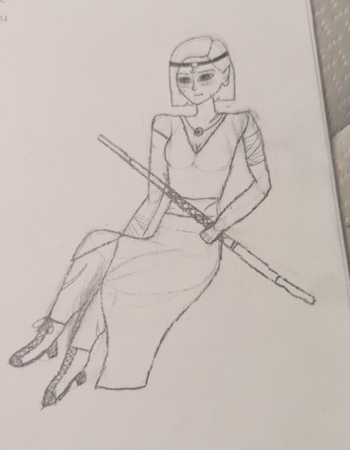
Character from “She Kills Monsters”

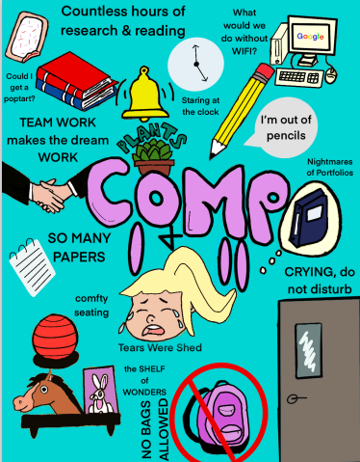
CHS Portraits

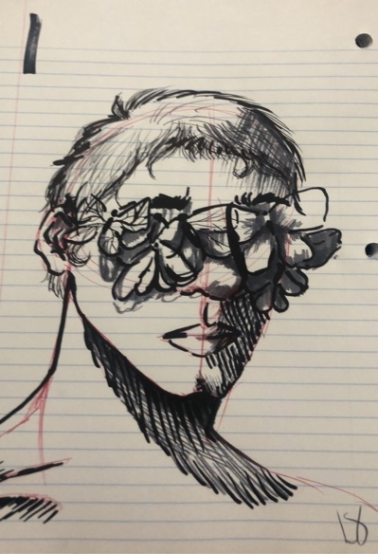
Lauren Schwenker’s drawings

Reasons Why You are Late
- Slept in
- Forgot what time your Kirkwood class is
- Extended Cougar Time schedule and no one told you
- Needing to grab a dessert before Kirkwood
- Jeff was being slow at Casey’s
- Needed gas
- “Wait, we had class?”
- Forgot my computer
- Could not find a parking spot
- Cows got out
- Senora won’t mark me tardy
- Band senior project
- Showering after PE
- “Car trouble”
- I fell asleep before Kirkwood
- Hit the red light

Class Songs
- “Memory I Don’t Mess with” – Lee Brice
- “I Like the Sound of That” – Rascal Flatts
- “Pursuit of Happiness” – Kid Cudi
- “Emo Girl” – Machine Gun Kelly
- “Heatwaves” – Glass Animals
- “Day N’ Nite” – Kid Cudi
- “The Spins” - Mac Miller
- “La La Land” – Bryce Vine
- “I Love my Homies” – Skeez
- “I’ll Always Remember You” - Hannah Montana

How You Know that Freshman Year Was the Best
- The song “Mo Bamba”
- “Mmmmm” – Juice WRLD
- Had a 4.0
- Freshman hall
- Caring about absences
- Barely had any homework
- Leaving Mr. Brindle’s class to get our book all the way in Freshman hall and taking our time
- Better grades in Spanish than English
- Mr. Vander Lugt
- Lower expectations
- Not worrying about college
- We only played Fortnite when we got home.
- Gavin’s basement every weekend

Things We Did in Comp Besides Doing Comp
Semantle
Weddle
Wordle
Quordle
Octordle
Heardle
Wardle
Poeltl
Sedecordle
Other class work
Nerdle
HayDay
Spamming friends with snapchats
Gossiping

Famous People We Grew Up Watching
The Splash Brothers
Tiger Woods
Tom Brady
LeBron James
Matt Damon
Alex Trebek
The Kardashians
Aidan Noonan
Nicole McDermott
The guys on Deadliest Catch

Contributors:
Grace Bergfeld
Maci Boffeli
Harley Bradtke
Lillian Bruns
Jack Carr
Brad Denemark
Kennedy Dossey
McKenna Gehl
Elizabeth Gibbs
Ally Hoffman
Keagan Lamey
Callie Lynch
Maddie Manternach
Isaac Martin
Cole Miller
Laura Otting
Tanner Simon
Megan Smith
Davis Trumm
Maggie Trumm
Bella Turnis
Jared Weber

